+ A Study of Life Together by Dietrich Bonhoeffer +

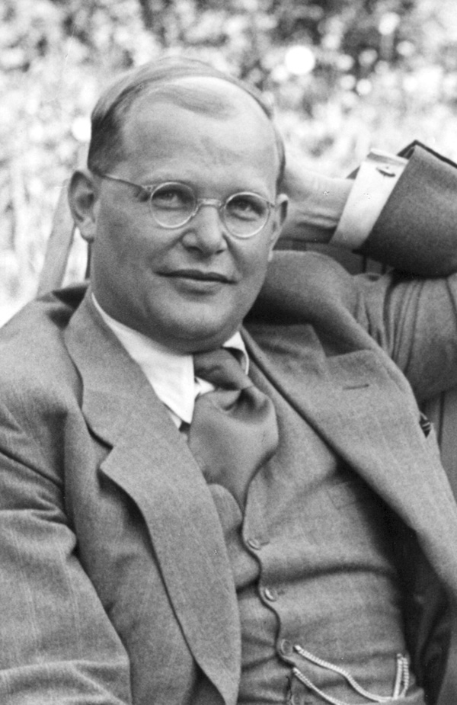
Introduction: The Life and Death of Dietrich Bonhoeffer.

Dietrich Bonhoeffer was born February 4, 1906 in Breslau. However, he grew up mostly in Berlin, where his father was a noted physician and psychiatrist. From his father he learned, as he wrote in his last letter from prison, what characterizes all that he wrote, an insistent realism, a “turning away from the phraseological to the real.” For him, Christianity could never be mere intellectual theory; doctrine divorced from life, or mystical emotion, but always must be responsible, obedient action, the discipleship of Christ in every situation of concrete every day life. For Bonhoeffer, doctrine and the Christian life were one and the same. He demonstrates for us the reality that the Christian faith is a confessing faith, one which teaches and proclaims the gifts of Christ and one which speaks forth through the mouth of Christians by the grace of God in the Holy Spirit. This is what led him to prison and to death. Six years before his imprisonment by the Gestapo he had written, “When Christ calls a man, he bids him come and die.”
While spending most of his youth in Berlin, he attended school, and was an athletic child born into a tight knit family. At the young age of 16 he knew he wanted to study theology and therefore went to study at Tübingen for a year and then back to Berlin in 1924. Some of the Berlin scholars at the time were Holl, Seeberg, Lietzmann. He was also familiar with Karl Barth and attended one of his lectures in Bonn. Bonhoeffer was an avid student, brilliant, and a scholar of sorts when it came to studying Martin Luther’s theology. He had a profound insight on Luther’s theology, especially such well known teachings such as law and gospel and the theology of the cross.
At the age of 21 he presented his doctoral thesis entitled, Communio Sanctorum, and received his doctorate with honors in 1927 at the University of Berlin. One of his most famous quotes came from this work; “the Church is Christ existing as community.” In this work he stressed the communal nature of the Church. His next written work, entitled Act and Being, was a qualifying thesis in which he defined the position and significance of dialectical theology. This enabled him to teach at the University of Berlin (1930).
From 1930-1931 he spent a year at Union Theological Seminary in New York for postgraduate work. Here he came into contact with Reinhold Niebhur. He assumed his post as lecturer in theology at Berlin in August of 1931. Later that winter of 1931-1932 he began lectures on Genesis that were later published as Creation and Fall. He also served as pastor in Charlottenburg for the students in technical school, where his services drew a large crowd. In 1933 He taught his final lectures at Berlin published in Christ as Center along with a seminar on G.W.F. Hegel.
These were tumultuous times in Germany. Hitler’s rise to power had been rapidly increasing every year since 1923 when he was released from prison. In 1933, Hitler was appointed Chancellor of Germany. This caused great struggle for the Christian churches of Germany. Eventually they were placed under the Nazi Gleichschaltung which basically amounted to forced acquiescence of Nazi policies. This encompassed all facets of life in Germany in addition to the church. Therefore, the Confessing Church was formed in 1933 in response to those churches that had caved in to Hitler. The Confessing Church made itself recognizable by an active voice against Hitler and the Nazis, especially with statements such as the Barmen Declaration which denounced those churches that had supported the Nazis.
In February of 1933, Bonhoeffer delivered a lecture over public radio in which he chastised the German public for hankering after a leader which would become a misleader. His radio program was cut off before he could finish. He fled to London, refusing to be a part of the German-Christian compromise with Hitler.
In spring of 1935 he was called by the Confessing Church to take charge of an “illegal,” underground seminary in Pomerania. The seminary was located in Finkenwalde, where he shared an emergency-built house with 25 vicars. This was life together, the life of the Christian community which is described and documented in Life Together (1938). This work, along with Cost of Discipleship, encompasses Bonhoeffer’s theological understanding of what it means to live as a Christian community in the body of Christ.
Sometime after writing these books and his commentary on the Psalms, the Gestapo closed the underground seminary and forbade Bonhoeffer from writing or publishing his books.
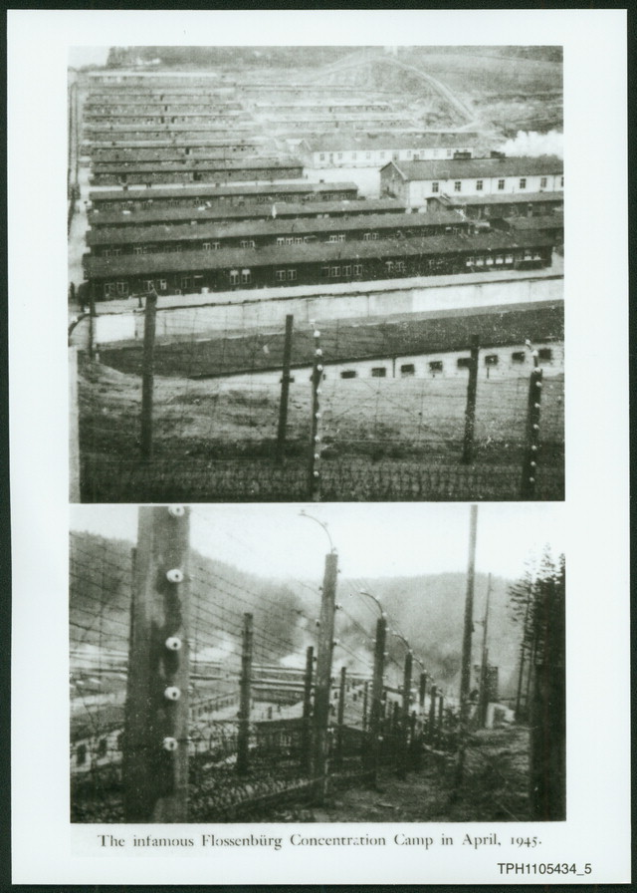
By this time, Bonhoeffer was already involved in the Abwehr resistance movement which was planning an attempt to assassinate Hitler. He was in the U.S. for a short stay and returned in 1939 even more committed to the Confessing Church and the resistance work. He saw a lack of response as an irresponsible cowardice and a flight from reality. He once said, “The sin of respectable people reveals itself in the flight from responsibility.” Here he acted in accord with his fundamental view of ethics, that a Christian must accept his responsibility as a citizen of this world where God has placed him.
On April 5, 1943, Bonhoeffer, his sister and brother-in-law, were arrested and incarcerated in Tegel, a military prison, and held there until October of 1944. Bonhoeffer spent time in several Gestapo concentration camps, including Buchenwald, Schönberg and finally Flossenburg. An estimated 73,000 victims were put to death at this camp and its sub-camps. On April 9, 1945, Dietrich Bonhoeffer was hanged; a day after he preached to fellow inmates on Isaiah 53, “By His stripes we are healed.” Before he was taken by the guards, he said this to one man near by, “This is the end, but for me it is the beginning of life.” On April 23, the 2nd U.S. Cavalry liberated Flossenburg. Through his written works, Dietrich Bonhoeffer continues to be one of the most influential Lutheran theologians of the 20th century and a modern witness for the faith in the midst of persecution and wickedness. Bonhoeffer, imprisoned for his faith, would no doubt agree with St. Paul who said, “I want you to know, brothers, that what has happened to me has really served to advance the Gospel, so that it has become known throughout the whole imperial guard and to the rest that my imprisonment is for Christ. And most of the brothers, having become confident in the Lord by my imprisonment, are much more bold to speak the Word of God without fear” (Philippians 1:12-14).

Introductory Questions for Life Together

Theme: Life together under the Word: Christ in the Christian community.

Prayer: Lord Jesus Christ, before whom all in heaven and earth shall bow, grant courage that Your children may confess Your saving name in the face of any opposition from a world hostile to the Gospel. Help them to remember Your faithful people who sacrificed much and even faced death rather than dishonor You when called upon to deny the faith. By Your Spirit, strengthen them to be faithful and to confess boldly, knowing that You will confess Your own before the Father in heaven, with whom You and the Holy Spirit live and reign, one God, now and forever. + Amen. (Collect for persecuted Christians, LSB).

- The Church today, at least in America, does not face bodily persecution anywhere near the severity witnessed in Nazi Germany. How does knowing the context of the era in which Bonhoeffer lived aid your understanding of this study?
- Read 1 Peter 4:12-19. What perspective does Peter give us on Christian suffering? Also Cf. Psalm 37, 70, 77, 94;Romans 5:1-5, 8:18; 1 Corinthians 1:3-11; Isaiah 53; Hebrews 2:10, 14, 4:15
- Since there we are separated by time and face a different context of life what is the value of studying this book and this man, Dietrich Bonhoeffer?
- There are certainly differences between our lives and Bonhoeffer’s life, what are some similarities we can draw as a Christian community gathered together here on this campus? What does Bonhoeffer offer to teach us from God’s Word that we might not find in another book?

Chapter One: Community - p. 17-26
Theme: Life together as a community in and through Christ our Lord.

Prayer: Almighty God, grant to Your Church Your Holy Spirit and the wisdom which comes down from above, that Your Word may not be bound but have free course and be preached to the joy and edifying of Christ’s holy people, that in steadfast faith we may serve You and, in the confession of Your name, abide unto the end; through Jesus Christ our Lord. + Amen. (Collect for the Church, LSB).

- In the opening pages of chapter one, Bonhoeffer establishes his thesis. What is a brief summary of this thesis? What is his reasoning in this theme/thesis? Read John 10:10 – what connection do you see between this verse and the thesis of Life Together.
- According to Bonhoeffer, what is the purpose for a Christian congregation to gather together? (p. 18).
- On p. 19, he writes, “The physical presence of other Christians is a source of incomparable joy and strength to the believer.” What does he mean by this? (p.19-20).
- How does Bonhoeffer’s warning about taking the fellowship of Christians for granted apply to our lives as members in the body of Christ, especially given our vocation as students?
- Under the subheading on p. 21 there are three main points in this section. What are they? (For the explanation – see p.21-26).
- In Luther’s Smalcald articles of 1537, he writes, “It must be firmly maintained that God gives no one His Spirit or grace apart from the external Word which goes before. We say this to protect ourselves from the enthusiasts who boast that they have the Spirit apart from and before contact with the Word. On this basis, they judge, interpret, and twist Scripture or oral Word according to their pleasure…In short, enthusiasm clings to Adam and his children from the beginning to the end of the world – fed and spread among them as poison by the old dragon…therefore we should and must insist that God does not want to deal with us human beings, except by means of His external Word and sacrament. Everything that boasts of being from the Spirit apart from such a Word and sacrament is of the devil.” Keeping this in mind, read Bonhoeffer’s words on p. 22; would he agree with Luther?

Prayer: I thank you my heavenly Father, through Jesus Christ, Your dear Son, that You have graciously kept me this day; and I pray that You would forgive me all my sins where I have done wrong, and graciously keep me this night. For into Your hands I commend myself, my body and soul and all things. Let your holy angel be with me, that the evil foe may have no power over me. + Amen

Chapter One: Community – p. 26-39

Theme: The Christian community is a Divine reality built and sustained by the love of God in Christ Jesus.

Prayer: Merciful God, we humbly implore You to cast the bright beams of Your light upon Your Church that we, being instructed by the doctrine of the blessed apostles, may walk in the light of Your truth and at length attain to the light of everlasting life; through Jesus Christ , our Lord. + Amen

- Bonhoeffer states that the Christian community is not an ideal, but a Divine reality. That is to say, the Christian community, the body of Christ, is not something which man can strive for nor create nor postulate hypothetically. Rather, it is the reality of Christ’s presence with His bride the Church. With this understanding, what does he mean when he speaks of human “wish dreams” corrupting the community? (p. 26ff).
- “God is not a God of emotions but the God of truth (p. 27).” What does he mean by this? What application of this statement can we make given today’s trends in mainstream Christian churches and denominations?
- On p. 28, Bonhoeffer talks about the common life of the Christian community. How does he describe us? What characterizes the Christian life?
- How does the answer to the previous question help support the fact that the Christian community is not an ideal but a Divine reality? (Also cf. p. 30).
- On pages 31-32, Bonhoeffer contrasts two communities. What are they? How are they different? Are there any similarities between the two?
- On pages 33ff he sets up another contrast of two types of love. What are the differences between these two types of love? What is the motivating factor or the “efficient cause” behind them?
- On page 35 Bonhoeffer wrote, “Human love makes itself an end in itself. It creates of itself an end, an idol which it worships, to which it must subject everything.” Read Romans 1:18-25. What does this reading from Romans, combined with what Bonhoeffer writes, teach us about our lives as Christians living in the 21st century? How do we make human love an end unto itself? Where does this seed of idolatry sprout in our lives?
- On page 38 Bonhoeffer wrote, “A purely spiritual relationship is not only dangerous but also an altogether abnormal thing.” What does he mean by this?
- How and where does God ground the spiritual realities of community together with the earthly reality of life as it has been given to us His children?
- Bonhoeffer clearly teaches us that there is a difference between human and spiritual love and also between human and spiritual communities. Are the two entirely incompatible? Can they ever coincide? Do we see this in Divine Service? (Cf. bottom of p. 39).

Prayer: I thank you my heavenly Father, through Jesus Christ, Your dear Son, that You have graciously kept me this day; and I pray that You would forgive me all my sins where I have done wrong, and graciously keep me this night. For into Your hands I commend myself, my body and soul and all things. Let your holy angel be with me, that the evil foe may have no power over me. + Amen

Chapter Two: The Day with Others - p. 40-57

Theme: Each new day the Christian community receives manifold gifts from God through prayer, hymns, and His Holy Scripture.

Prayer: Faithful God, whose mercies are new every morning, we humbly pray that You would look upon us in mercy and renew us by Your Holy Spirit. Keep safe our going out and our coming in, and let Your blessing remain with us throughout all our days. Preserve us in Your righteousness, and grant us a portion in that eternal life which is in Christ Jesus our Lord. + Amen

- Bonhoeffer begins this chapter about the Christian’s day spent with others. How do we begin our mornings? How is this different than the community in which Bonhoeffer is writing?
- What significant events does he call us to reflect upon each new day? (p. 40)
- How do Luther’s morning and evening prayer help to focus the mind of a Christian in the morning and in the evening? How then would we begin to describe the rhythm of the Christian life – i.e. if it were to have shape, what would it look like?
- Bonhoeffer asks a question on pg. 44 of importance for us. How can God’s Word be at the same time prayer to God? What are some of the answers he provides in the next few pages? What are your conclusions on this question?
- Beginning on page 47, Bonhoeffer addresses the meaning and value of praying the Psalter (book of the Psalms). What are three reasons he provides for the meaning of praying Psalms? (pg.47-50).
- From pages 50-57, Bonhoeffer takes up the Christian community’s daily reading of Scripture. He reminds us that God’s Word is a revealed Word for all men at all times. However, these were written some time ago. Therefore, what dangers does he warn us against as we read Scripture within the Christian community? Why might people object to reading Scripture as a Christian community?
- On page 53, why does he instruct or advise that Scripture should be read as a whole (corpus) and done continually (lectio continua)? What benefits does this offer to us in the Christian community?
- On page 54, he speaks concerning the various troubles and trials a Christian experiences in this life. What comfort does he point us to that is especially helpful as students?
- Does Bonhoeffer support the Sola Scriptura of the Reformation? What reasons would you give for your answers from his writing? (p.55).
- What does he identify as the worst sin one can commit while reading Scripture? (p. 56).

Prayer: I thank you my heavenly Father, through Jesus Christ, Your dear Son, that You have graciously kept me this day; and I pray that You would forgive me all my sins where I have done wrong, and graciously keep me this night. For into Your hands I commend myself, my body and soul and all things. Let your holy angel be with me, that the evil foe may have no power over me. + Amen

Chapter Two: The Day with Others – p. 57-75

Theme: Hymns, prayers, and fellowship unite the Christian community under the Word of God.

Prayer: Almighty God, send Your Holy Spirit into our hearts that He may rule and direct us according to Your will, comfort us in all our temptations and afflictions, defend us from all error, and lead us into all truth that we, being steadfast in faith, may increase in all good works and in the end obtain everlasting life; through Jesus Christ, our Lord.
+ Amen.

- Continuing his discussion on the Christian’s day with others, Bonhoeffer takes up the subject of singing. With whom does he connect the song of the Christian community? Why is this important for us as a community? (p. 57). Cf. also Revelation 7:9-12. What are some other well known “songs” in Scripture?
- According to Bonhoeffer, what is the role of music and hymnody in the Church? (p. 59). Therefore, what benefits do church music, singing, etc. give to our life in the Church community?
- Bonhoeffer calls our corporate prayers the voice of the Church. What are some difficulties he raises that are prominent within a praying Christian community? (p.62).
- How is the prayer of the Christian community best formed and shaped? Cf. p. 62 and 64.
- Reflecting on the book thus far, why do you think he tends to emphasize the topic of prayer in the Christian community as one of importance?
- Bonhoeffer says that Scripture speaks of 3 kinds of table fellowship, daily at the table, the fellowship at the Lord’s table, and the final fellowship in the kingdom of God (p. 66). He rightly asks, “To know Jesus Christ in the presence of these gifts – what does this mean?” How does he answer his own question? What applications can we make for this group of LSF?
- He speaks of a unity between prayer and work as a “break-through” for the Christian. How does he explain this for us? What does this mean for our work as students?
- “The sustenance that God provides becomes a consolation of the afflicted; for it is the token of the grace and faithfulness with which God supports and guides His children” (p. 72). What is the Scriptural connection between work and being fed? How does this differ from what the world teaches us about work and daily bread?
- There are many good and salutary things mentioned in this chapter concerning the Christian’s daily life together under the Word of God. Bonhoeffer suggests a good rhythm of life for our Christian faith. Name some ways in which we have complicated our lives, therefore making such a rhythm and pattern of life more difficult.

Prayer: I thank you my heavenly Father, through Jesus Christ, Your dear Son, that You have graciously kept me this day; and I pray that You would forgive me all my sins where I have done wrong, and graciously keep me this night. For into Your hands I commend myself, my body and soul and all things. Let your holy angel be with me, that the evil foe may have no power over me. + Amen

Chapter Three: The Day Alone – p.76-89

Theme: The Christian spends time alone for meditation, prayer, and intercession, so that they are strengthened for the benefit of the community.

Prayer: Almighty and everlasting God, You make us both to will and to do those things that are good and acceptable in Your sight. Let Your fatherly hand ever guide us through prayer, meditation, and intercession through Your Son Jesus Christ. Grant that Your Holy Spirit ever be with us to direct us in the knowledge and obedience of Your Word that we may obtain everlasting life; through Jesus Christ, our Lord. + Amen.

- In the previous chapter, we learned of the many benefits that come from a Christian community that gathers together. However, can a Christian community gather together for the wrong reasons? Cf. p. 76.
- “Let him who cannot be alone beware of community…but the reverse is also true: Let him who is not in community beware of being alone” (p.77). These two statements appear to be paradoxical. What does he mean by saying this? What does Bonhoeffer want us to learn from these two statements? How can this apply to this community of LSF at Stanford?
- For all the benefits of silence, Bonhoeffer also indicates that there is a negative silence. Cf. p. 80 and this quote “There is such a thing as forbidden, self-indulgent silence, a proud offensive silence.” Do you think that this quote and portions of this page refer to his outspoken activities against the Nazis or is that inferring too much? What might this say about our response to activities and statements around campus that we know are wrong? What is the Christian response to public events of tragedy and or error?
- Christian time alone in devotion is not meant to be conducted willy-nilly. What three motifs does Bonhoeffer use to focus the devotional time alone? What does this suggest for our own devotions?
- What is the purpose of meditation upon God’s Word? (Cf. p. 81-84).
- With whom and from where does Christian prayer, both public and private, begin? (Cf. p.84-85).
- How does Bonhoeffer define intercession in distinction from prayer? Describe the application of intercession within the Christian community. (Cf. p. 85-87). How is this done in our community? What are some ways we can continue this practice?
- “Every day brings to the Christian many hours in which he/she will be alone in an unchristian environment. These are the times of testing” (p. 88). Describe some of the ways you have been tested during your time at Stanford. How does testing reveal where one’s faith is anchored? There are two distinctions to be made: first, that God tests us and second, that the devil tempts us – these are two different things. Explain using: 1 Corinthians 10:12-13; Hebrews 4:15; James 1:3; Matthew 4:1-11.

Prayer: I thank you my heavenly Father, through Jesus Christ, Your dear Son, that You have graciously kept me this day; and I pray that You would forgive me all my sins where I have done wrong, and graciously keep me this night. For into Your hands I commend myself, my body and soul and all things. Let your holy angel be with me, that the evil foe may have no power over me. + Amen
Chapter Four: Ministry – p. 90-109

Theme: Justification by faith leads the Christian community to actively serve others through meekness, listening, helping, bearing, and proclaiming.

Prayer: Heavenly Father, grant Your mercy and grace to Your people in their many and various callings. Give them patience, and strengthen them in their Christian vocation of witness to the world and of service to their neighbor in Christ’s name; through Jesus Christ, our Lord + Amen.

- Bonhoeffer uses the word ministry in this chapter differently than we think of ministry. How is it used in this chapter? What things are a hindrance to the Christian community that ministers? How do we encounter this either on campus or in our daily lives?
- The tongue is a two-edged sword, speaking both words of wickedness and also words of compassion. First, what does Bonhoeffer tell us is dangerous about the tongue? Then, what does he suggest as a goal for the proper use of the tongue in a Christian community?
- Do we risk anything in helping others? Why is it hard to “think little of ourselves”? (p. 94). How can LSF serve others with meekness?
- What kind of listening does Bonhoeffer have in mind for us (p. 97 ff.)? How can Christian love be expressed through listening to other Christians in our community?
- What is the two-fold aspect of helpfulness (p. 99)? What are some concrete ways that LSF has done this and can continue to do this in the future both on campus and at Trinity?
- What role does our freedom as Christians play in bearing one another’s burdens (p. 100-103)? Luther once wrote in his famous work on Christian freedom, “A Christian is a perfectly free lord of all, subject to none. A Christian is a perfectly dutiful servant of all, subject to all.” (Cf. 1 Cor. 9:19; Rom. 13:8) What insight does Luther add to the ministry of bearing as discussed by Bonhoeffer?
- In a day and age where the phrase “you can’t judge me” (or any variation on that theme) is common, what does Bonhoeffer tell us is unavoidable (p. 107)? How do Christians properly judge matters in life? Cf. Galatians 1:6-10; 1 Timothy 6:3-5; 2 Timothy 1:8-14, 3:1-5. How does this apply to life on campus or in our community together at LSF?
- Genuine authority and the authority that the world values are two different things. What are the foundations and goals of these two different views on authority? For example, where does authority come from? How is it exercised? What is its purpose? How is authority properly understood within the Christian community? Mt. 28:18; Rom. 13:1.

Prayer: I thank you my heavenly Father, through Jesus Christ, Your dear Son, that You have graciously kept me this day; and I pray that You would forgive me all my sins where I have done wrong, and graciously keep me this night. For into Your hands I commend myself, my body and soul and all things. Let your holy angel be with me, that the evil foe may have no power over me + Amen.

Chapter Five: Confession and Communion – p. 110-122

Theme: The Christian community is bound together in fellowship with one another chiefly through the fellowship of forgiveness of sins through confession and the Lord’s Supper which comes through God’s grace in Christ Jesus.

Prayer: Almighty God, merciful Father, by Word and Sacrament You have created Your Church in this world to be a godly communion and family, united by baptism into the body of Christ. Grant to us, Your fellowship of believers, steadfast confidence and trust in Your gracious gifts spoken unto us through confession and absolution of sins and in the reception of our Lord’s body and blood for live and salvation. Through Jesus Christ Your Son our Lord + Amen.

- Bonhoeffer begins the chapter on Confession and Communion by saying that he who is alone with his sin is utterly alone. Why is it dangerous to live alone in our sin? What comfort does confession offer us? 1 John 1:9; Psalm 51 Recall Luther’s words about confession in the Small Catechism. How does Trinity and LSF provide for our need of confession and forgiveness of sins as a Christian community?
- What is the effect of individual’s sin upon the whole community? What effect does the confessed sin have on the community? Since we as a community suffer the effects of one another’s sin and the blessings of Christ’s forgiveness, how can we challenge, confess, and speak into one another’s lives? (p. 112-113). 1 Cor. 12:12-26; 2 Cor. 1:7
- What is the importance of confessing our sins to one another in the community? What is breakthrough does Bonhoeffer describe that follows confession? (p. 112-115). James 5:16.
- What does it mean that we are given a new life through confession? (p. 115). What are the characteristics of this new life – what does it look like? How then are baptism and confession connected? Romans 6.
- It is for the sake of certainty that confession should deal with concrete sins. What does he mean by certainty here? Is it always necessary to enumerate our concrete sins? What happens if we make confession a law? (p. 116-117). Here we can also examine Luther’s words on confession in the Small Catechism. Psalm 19:12, 32:3&5, 51:1-4
- According to Bonhoeffer, what are two dangers that face a Christian community that practices confession with each other? How do we avoid these dangers?
- What does the confession of sins prepare us for? How?
- How does the Lord’s Supper bind us together as a Christian community gathered together under God’s Word? Cf. 1 Corinthians 10:14-22. Acts 2:42-44.
- As a result of reading this book and the discussions of our community of LSF and Trinity, what are some ways we can grow together as a Christian community? How can this Christian community serve the Lord on this campus either in word or deed?
- What are some ways that I can continue to make sure your spiritual needs are met as we gather together as LSF both together and as an extended community at Trinity?

Prayer: I thank you my heavenly Father, through Jesus Christ, Your dear Son, that You have graciously kept me this day; and I pray that You would forgive me all my sins where I have done wrong, and graciously keep me this night. For into Your hands I commend myself, my body and soul and all things. Let your holy angel be with me, that the evil foe may have no power over me + Amen.

Most of this introduction is taken from the introduction to Life Together in the 1954 printing from Harper Collins publishing. Also from www.dbonhoeffer.org, Lutheran Cyclopedia, and The Encyclopedia of the Lutheran Church.
Dialectical theology – term used to describe the theology of Karl Barth, who stressed that God is transcendent, the “wholly other”, so that He cannot be characterized with a simple formula. Statements about God must perhaps be paradoxical, with each affirmation balanced by a negation to do justice to God’s infinite transcendence.
Luther, Martin. Christian Liberty. Fortress Press: Philadelphia, 1957. p. 7.

